# Lab: Selenium Basics

This document defines the homework assignments from the ["QA Automation" Course @ Software University](https://softuni.bg/trainings/1584/qa-automation-march-2017).

Please submit as homework a single zip / rar / 7z archive holding the source code or whatever approach is needed to finish your tasks

# NUnit Tests against Bank Account

## Bank Account

* Write a test that check that exception is thrown when you **instantiate BankAccount** with negative money
* Write a test that check Withdraw() method get right amount of money for bank transfer
  + If withdraw amount is **less** than **1000** transfer fee is **5%** of withdrawn amount
  + If withdraw amount is **greater** than **1000** transfer fee is **2%** of withdrawn amount

## Asserts

Like you see in presentation, you can assert so much things. There is no "right" way to assert something. It is up to you to choose how to assert. Write **five** more tests against BankAccount that test its functionality. Use five different type of asserts for these tests.

# Selenium

## Google Search

Write a **test** that **open browser** and navigate to **http://www google.com**. Then **search** for the best browser automation tool "**Selenium**". Click on **first link** and check if browser will open [**http://www.seleniumhq.org**](http://www.seleniumhq.org).

**Assert** that title is "Selenium - Web Browser Automation"**.**

### Examples

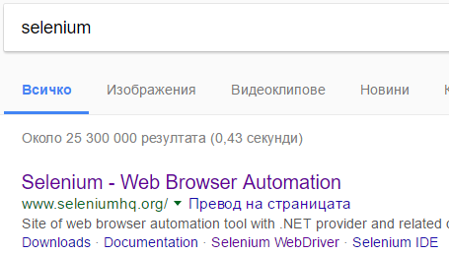

## QA Automation

Write a **test** that **open browser** and navigate to [**http://www.softuni.bg**](http://www.softuni.bg). Then by using **navigation bar** navigate to QA Automation course page.

**Assert** that there are two heading tags **<h1>** and **<h2>** that contains **"Курс QA Automation - март 2017"**

### Examples



## DemoQA Registration page

Write a **test** that **navigate** to [**http://www.demoqa.com**](http://www.demoqa.com) and open **registration page.**

**Assert** that registration page is open.

### Examples

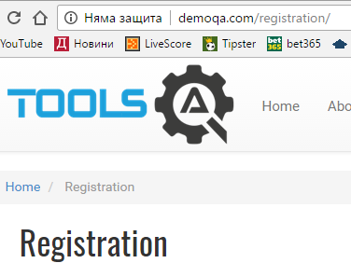

## DemoQA Registration negative tests

After last test you can be sure that registration page is open correctly. Now for next tests you can navigate directly to [**http://demoqa.com/registration/**](http://demoqa.com/registration/)**.** Write at least **five negative tests** against registration form. Your tests have to check **five** **different error messages** in the registration form.

### Examples

First and Last names cannot be empty.

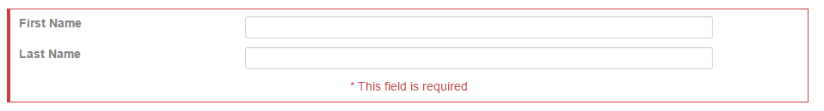

Phone number need to be at least 10 Digits



Email must be valid string



Password cannot be empty

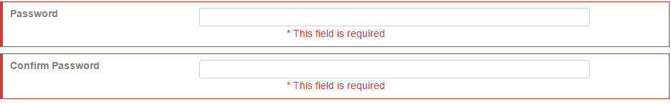

Passwords should match

